[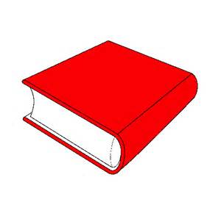](https://www.bing.com/images/search?q=dibujo+de+libro&view=detailv2&&id=B0F123C9B4EEBC79FAEF36C3D098FEF0DA4B0AB1&selectedIndex=15&ccid=HFHk18xd&simid=608022453570242584&thid=OIP.M1c51e4d7cc5de213b8dfb6e92abe0405o0)

[](https://www.bing.com/images/search?q=dibujo+de+libro&view=detailv2&&id=6DCAB0E0AF0873546DA89F0BEE3E43F0D5A1BF63&selectedIndex=21&ccid=k6WRx4vX&simid=608044048654536462&thid=OIP.M93a591c78bd7f8b644ebaaeaa91a3a0ao0)